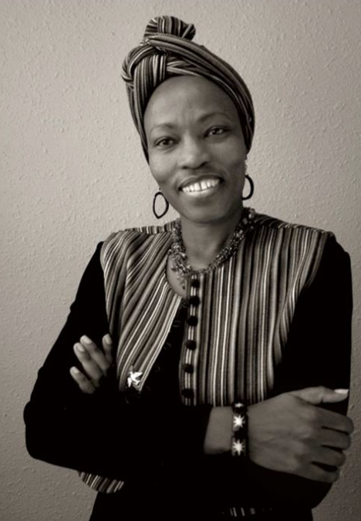

We are looking forward to a visit from Dr. Karambu Ringera, founder of “International Peace Initiatives” of Meru Kenya at our meeting on Monday, May 20th. Dr. Ringera will share with us the many insights she has gained through her experience in creating a home for AIDS orphans, empowering women, youth leadership training, peace-building initiatives and innovative and sustainable models of development in order to effect change at a local level and well beyond. She is a truly inspiring example of what it means to live aligned with your values and take action for the common good in today’s world. We hope you will be able to join us her presentation.

